- Class diagram

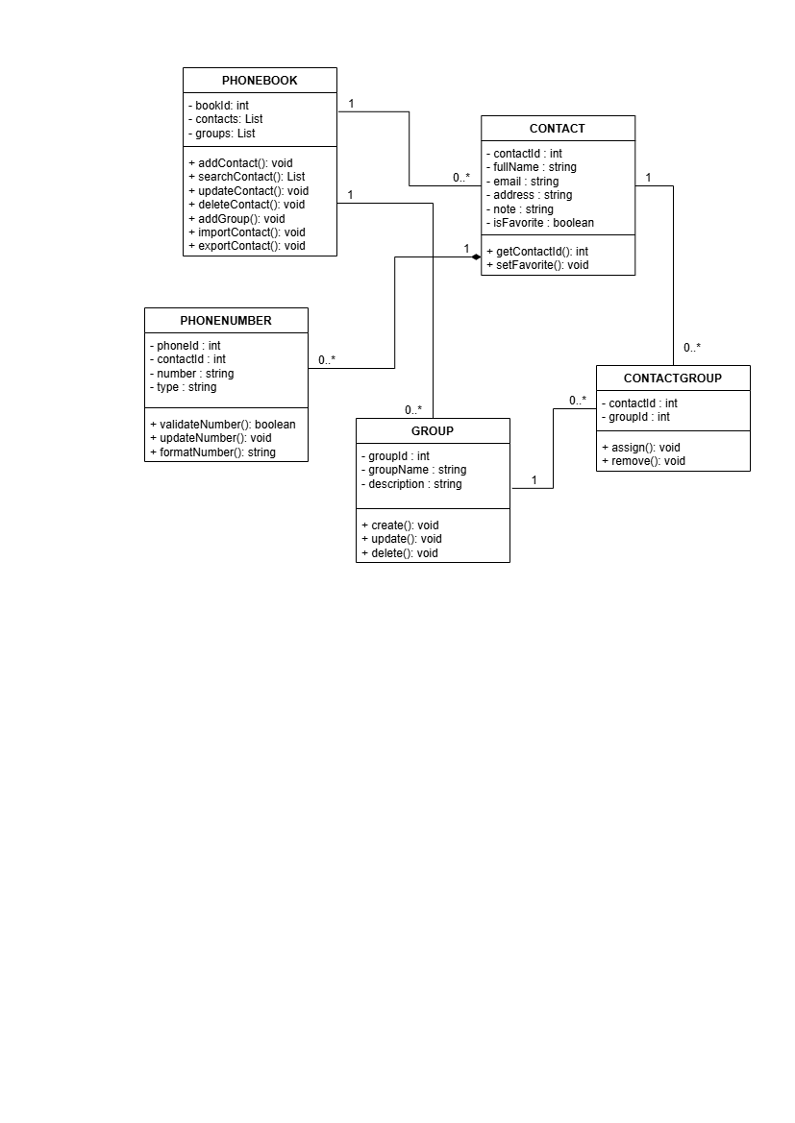

Class Descriptions

Class | Attributes | Main Methods | Responsibility
PHONEBOOK | bookId, contacts, groups | addContact(), searchContact(), updateContact(), deleteContact(), addGroup(), importContact(), exportContact() | Acts as the main controller handling overall system operations, contact/group management, and import/export tasks.
CONTACT | contactId, fullName, email, address, note, isFavorite | getContactId(), setFavorite() | Represents an individual contact entry and tracks personal details along with favorite status.
PHONENUMBER | phoneId, contactId, number, type | validateNumber(), updateNumber(), formatNumber() | Stores phone number details, checks input validity, and handles formatting.
GROUP | groupId, groupName, description | create(), update(), delete() | Manages contact categories, allowing users to organize contacts into distinct groups.
CONTACTGROUP | contactId, groupId | assign(), remove() | Connects contacts and groups together to support many-to-many relationships.

5.2. Relationship Summary
- PHONEBOOK to CONTACT (1 to 0..*): One phone book stores and manages all your contacts.
- PHONEBOOK to GROUP (1 to 0..*): One phone book holds all the custom groups you create to organize people.
- CONTACT to PHONENUMBER (1 to 0..*): Each contact can have multiple numbers (like home or work). If you delete a contact, all of their numbers are deleted automatically.
- CONTACT to GROUP via CONTACTGROUP (1 to 0..*): CONTACTGROUP links contacts and groups together so that a single contact can belong to several groups, and a single group can hold multiple contacts.

